ADITHYA R
192311369

14.Create a Virtual Hard Disk and allocate the storage using Vmware Workstation.
AIM: To create a Virtual Hard Disk (VHD) and allocate the required storage capacity while setting up a virtual machine using VMware Workstation, in order to understand disk configuration and storage management in virtualization
PROCEDURE:
*Launch VMware Workstation on the host system.
*Click Create a New Virtual Machine from the home screen.
*Select Typical (recommended) and click Next.
*Choose the operating system installation source (ISO file / installer disc / install OS later).
*Select the Guest Operating System type and version, then click Next.
*Enter a name for the virtual machine and choose a location to store VM files.
*In the Specify Disk Capacity screen, enter the required virtual hard disk size (e.g., 40 GB).
*Choose Store virtual disk as a single file or Split virtual disk into multiple files.
*Click Next, review the configuration, and then click Finish.
*VMware Workstation creates the virtual hard disk and allocates the specified storage to the virtual machine.

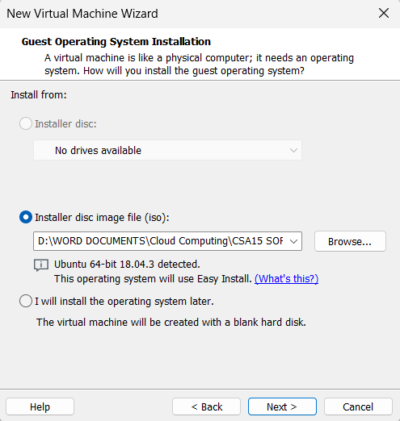

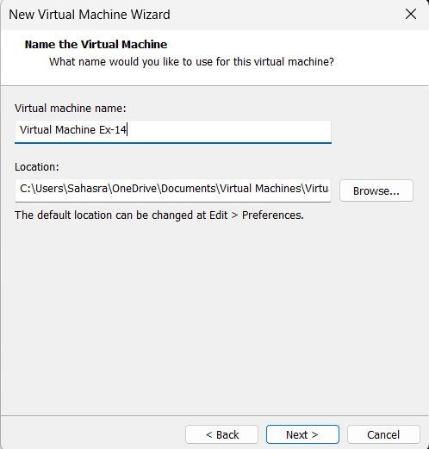

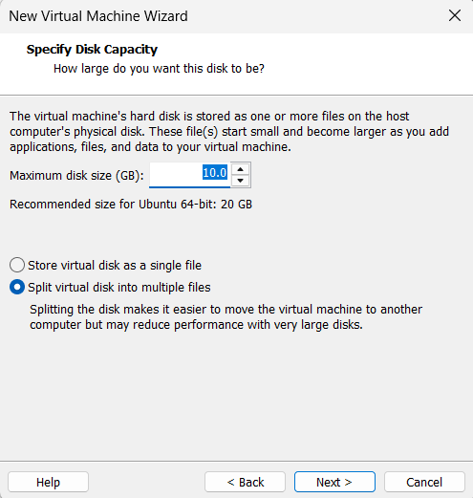

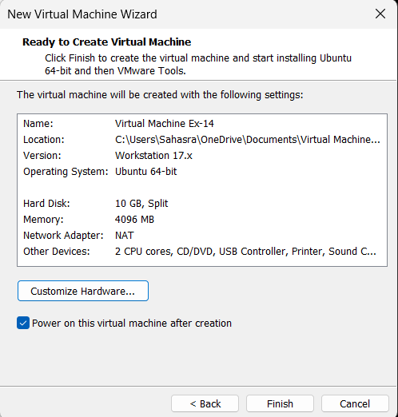
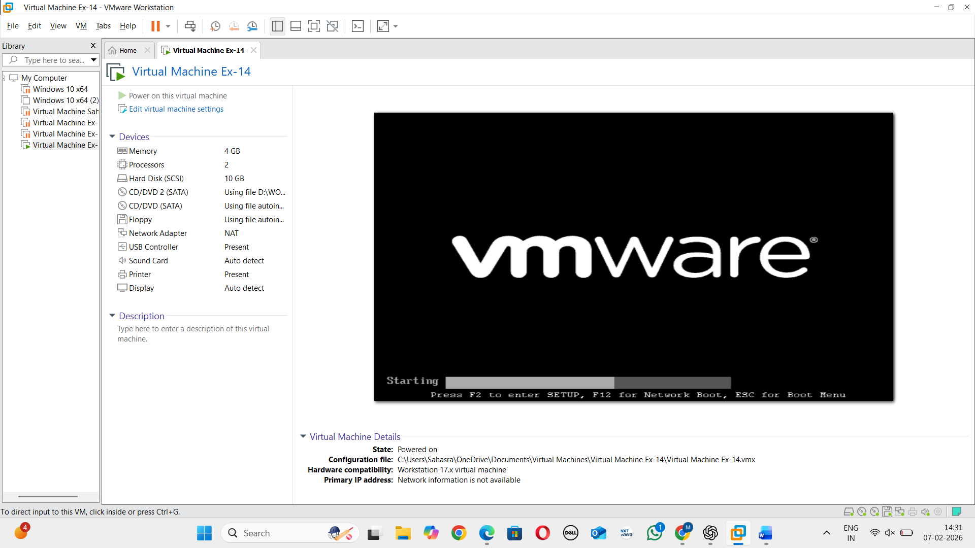
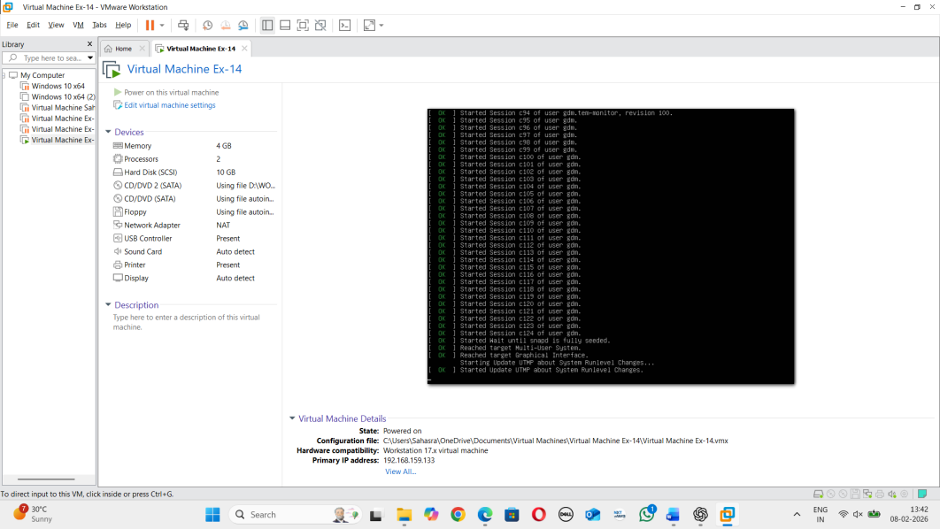

RESULT:
A Virtual Hard Disk was successfully created and allocated with the specified storage capacity using VMware Workstation. The virtual machine was configured properly and is ready for operating system installation and further use.

